# Trace Report 2 – Abhimanyu bhat – 11732514- ass 4

## Tracing bug for incorrect fine levied

It is seen that the fine is levied only half the actual amount.

1. The main point of entry is in the **returnBook** method of Main class

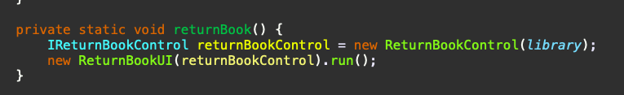

2. Portion of the code where the failure occurred. We can see that this is where the **overDueFine** is being outputted to the user.

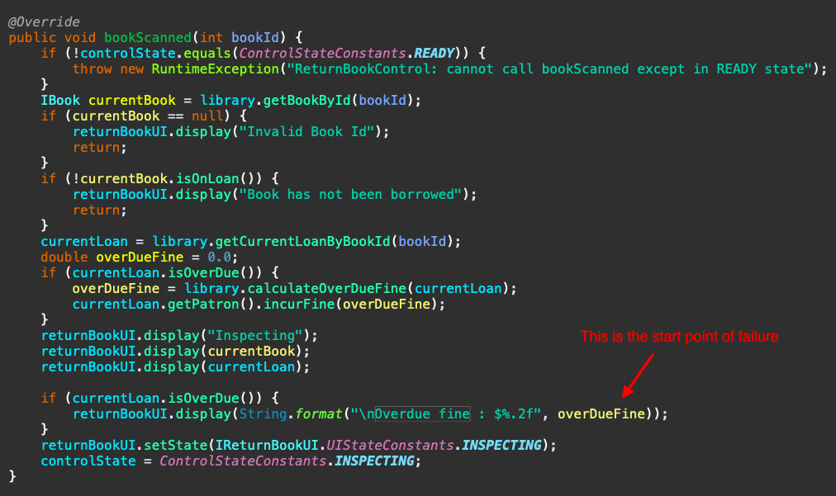

3. Trace for when book is returned 3 days after due Date. The value of **daysOverDue** should have been 3 but is 1 instead.

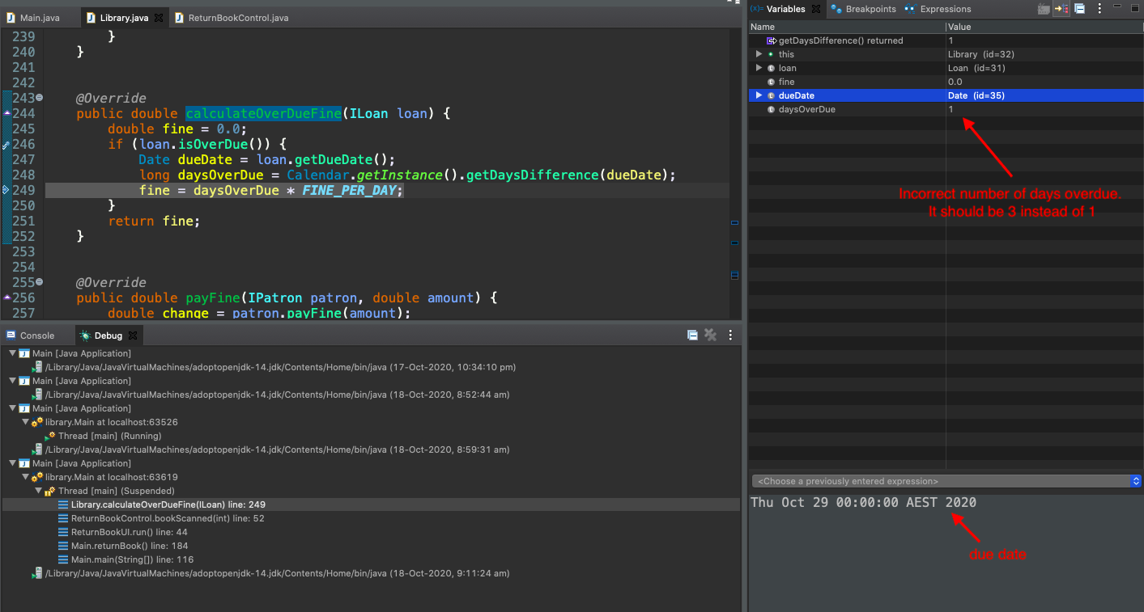

4. The screenshot below shows current date to be 1st of November 2020.

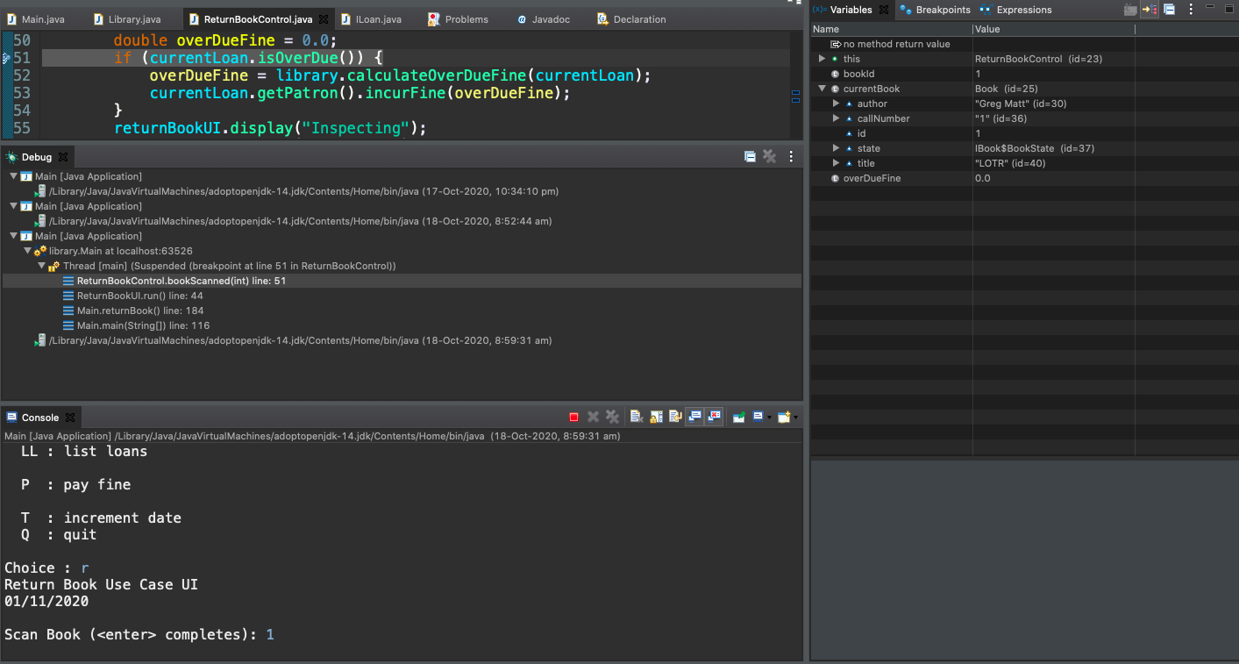

5. Solution displaying the **diffDays** correctly calculated as 8 when the target date is 20th October 2020 and the current date is 28th October 2020.

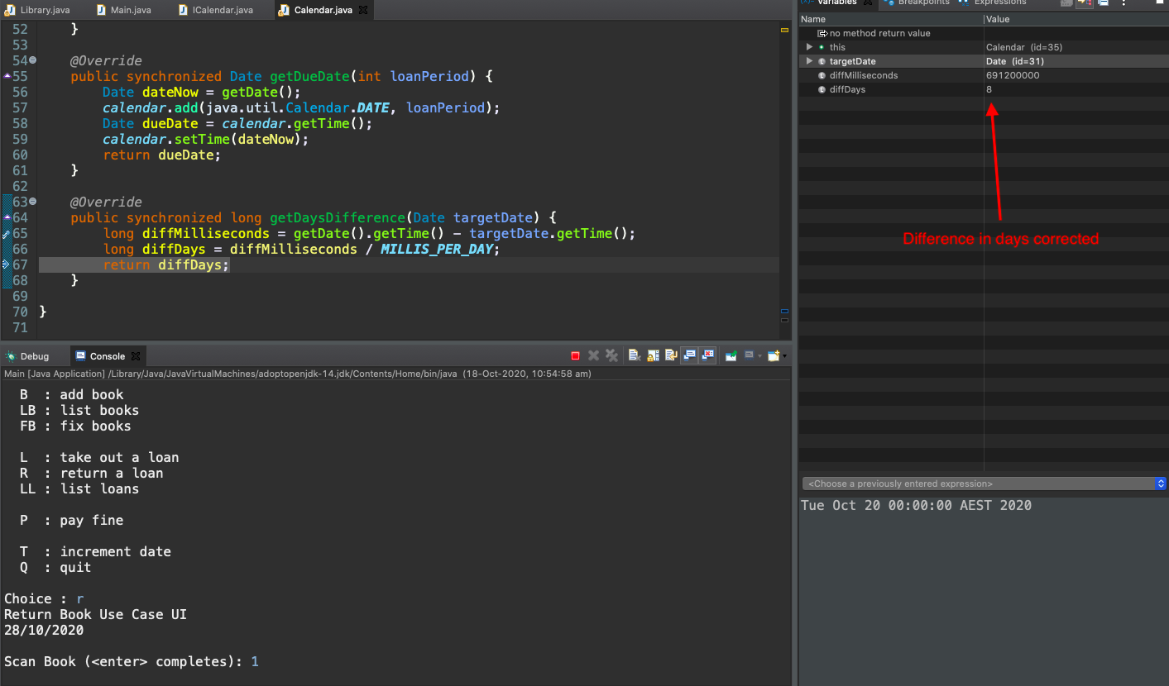

7. Solution Output:

a) 8 days after due date:

Current date: 28th October 2020

Due date: 20th October 2020

Correct calculation of overdue fine is $8.00 for 8 days.

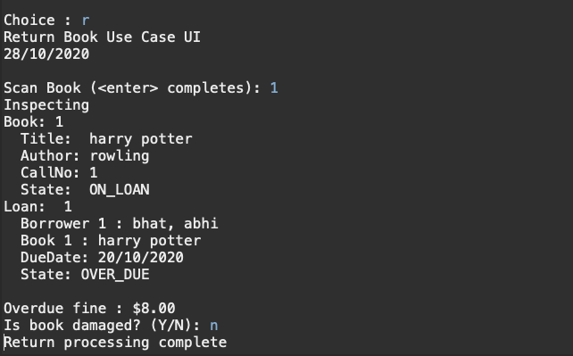

b) 1 day after due date-

Current date: 23rd October 2020

Due date: 22nd October 2020

Correct calculation of overdue fine is $1.00 for 1 day.

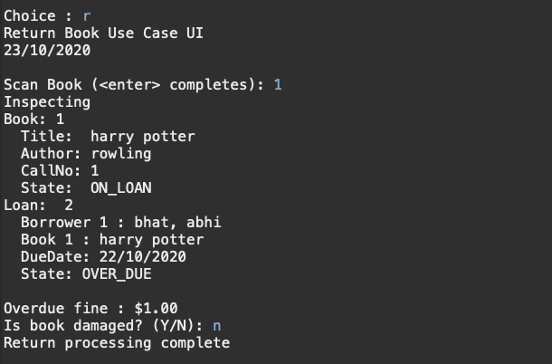

c) 2 days after due date-

Current date: 24th October 2020

Due date: 22nd October 2020

Correct calculation of overdue fine is $2.00 for 2 days.

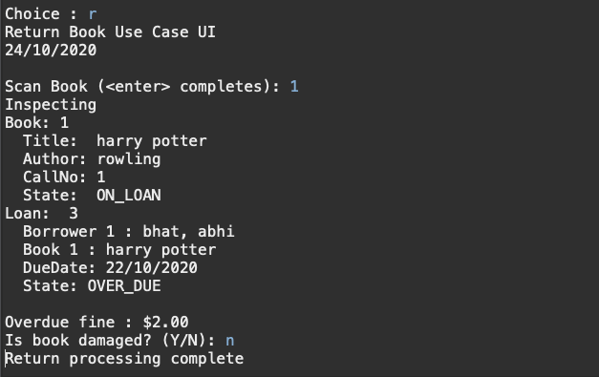

d) 3 days after due date-

Current date: 29th October 2020

Due date: 26th October 2020

Correct calculation of overdue fine is $3.00 for 3 days.

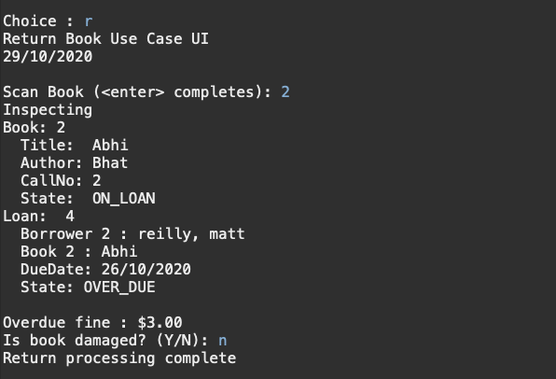

e) Output for 4 days after due date-

Current date: 26th October 2020

Due date: 22nd October 2020

Correct calculation of overdue fine is $4.00 for 4 days.

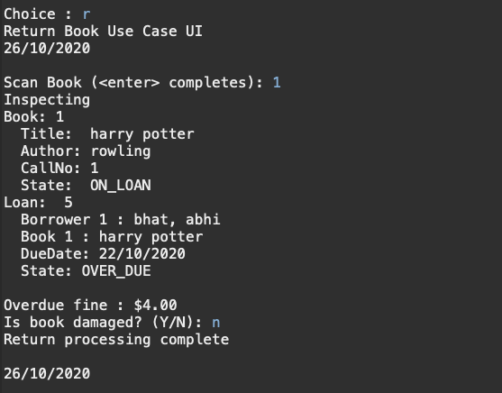

f) Output for 7 days after due date-

Current date: 29th October 2020

Due date: 22nd October 2020

Correct calculation of overdue fine is $7.00 for 7 days.

